**Elementary**

**Science Fair Notebook**

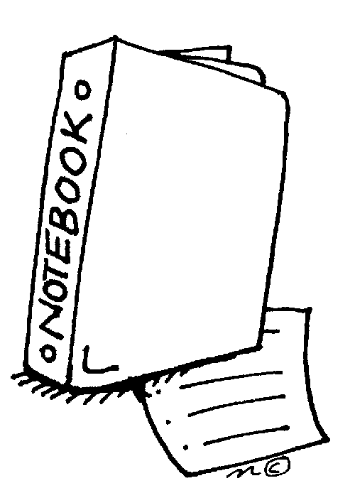

**Name: ________________________**

**Project Due Date: _______________**

**Project Overview**

**What is a science fair project?**

The science fair project is a long-term project where you will plan, conduct, and share results from your own independent investigation. The project includes complete the pre-planning steps, conducting a science experiment, recording your data in a science notebook, analyzing your data, and creating a tri-fold poster to share your project. You can use this notebook to help you with the project process.

**What makes a good project?**

The first step to completing a good science fair project is to choose a topic that interests you. Students that have excellent projects do research before they begin. They really understand the science behind their topic and use their knowledge to design an interesting experiment. Another thing that makes a great project is originality. Try to come up with your own question. There are a lot of examples of projects on the Internet. If you are stuck, use these as jumping off points, but try to make the project your own. When you conduct your experiment, do multiple trials. The more data you collect, the better. Also, if something doesn’t go as planned and you have an idea to test why, keep going, this is what scientists do. Finally, you want your poster to be informative, clear, and attractive. You have put a lot of work into planning and conducting your experiment. A well-planned poster will help others see this.

**What should my poster look like?**

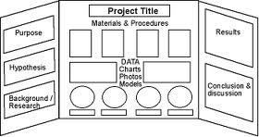 Your poster shares what you learned in your experiment. You will not be able to conduct your experiment during the science fair. In addition to your poster, you should have a science notebook with your research, sources, data, and observations. You can use this packet as your notebook or it could be a spiral notebook that you use while researching, collecting data and making observations.

**Science Fair Timeline**

|  |  |  |
| --- | --- | --- |
| **Dates** | **Steps** | **Completed** |
| Nov. 24th | **Teacher Approval/Registration Form**  Before you can begin your experiment your teacher must sign an approval form. The form is on the last page of this notebook. |  |
| Nov. 24th | **Topic and Question**  Read science magazines, make observations, and find out what interests you. Based on your interests you will develop a testable question. A testable question is a question that can be answered through experimentation. |  |
| Dec. 15th | **Research**  After you have chosen a question you need to research more about your topic. Come up with some questions related to your topic and search for the answers. Then write a paragraph about what you learned. |  |
| Dec. 15th | **Hypothesis**  Write a hypothesis that shares your reasoning (don’t forget to include *because*). Use what you learned doing background research to help you write your hypothesis. |  |
| Dec 15th | **Experiment: Materials and Procedures**  Think about how you will conduct a fair experiment by considering the variables you will control. List your materials, including quantities. Write step-by-step procedures so that others could replicate your experiment. |  |
| Jan. 9th | **Collect Data & Make Observations**  This is the fun part! Set up your experiment, gather data, and make observations. Take your time and collect accurate data. If you need to adjust your procedures that is fine. You may even come up with another thing you want to test as you learn more! Be sure to run your experiment multiple times. |  |
| Jan. 14th | **Data Charts and Graphs**  Collecting data and observations throughout your experiment is very important. Record everything! Then use charts and graphs to organize your data so that others will be able to see what you learned. |  |
| Jan. 20th | **Conclusion**  Share what you learned from your experiment in your conclusion. Your conclusion will be 1 – 3 paragraphs long. |  |
| Jan. 23rd | **Poster**  Your poster should include all the sections of your project in a clear display. The goal of the poster is to teach others about your experiment and what you learned through your investigation. |  |

**Topic Brainstorm**

In this section you will record ideas about your interests. This will help you to pick a topic and develop a question for your science fair project. Fill in each text box.

1. What do you like to do outside of school? (examples: art, theater, sports, build things, cook, etc.)

4. Free Write: In the space below write about the topics you think you might be interested in for the science fair. What ideas do you have right now?

3. Take the science interest survey on the next pages. List the science disciplines that you are interested in.

2. What is your favorite thing you have done related to science? (examples: experiments, tv shows, museums, etc.)

**Science Interest Survey**

**Directions: Answer each question with “yes”, “no” or “kinda”**

1. Do you like building or repairing machines?
2. Do you enjoy gardening and working with plants?
3. Are you curious to understand things like gravity and magnetism?
4. Does observing the behavior of different people fascinate you?
5. Do you enjoy working on computers or learning about how computers work?
6. Do you like to go hiking or snorkeling so that you see different animals in their

natural environment?

1. Do you enjoy learning about the forces of nature like weather and earthquakes?
2. Do you enjoy learning about memory and how our brain works?
3. Are you curious about the way different animals grow, develop, and live?
4. Are you interested in science fiction stories involving faster than light travel and

"beams" that do amazing things?

1. Do you want to understand more about how people are affecting the environment?
2. Do you enjoy learning about outer space and astronauts?
3. Do you enjoy learning about lakes, rivers, the ocean, and beaches?
4. Have you built inventions or other things for fun and not a school project?
5. Do you enjoy learning about chemicals and things that bubble, fizz, or explode?
6. Do you enjoy discovering new ways to recycle, restore, or re-use old stuff?
7. Do you like to go on drives or hikes specifically so that you can see interesting

mountains, rock, or caves?

1. Do you enjoy watching or participating in sports?
2. Do you like learning about what makes us healthy and what makes us sick?
3. Are you interested in how to build roads, bridges, and buildings?

**What kinds of science are you interested in?**

**Directions: Circle the numbers that you answered “Yes” to on the other side**.

**These are the kinds of science that you are interested in!**

1. Engineering: Learning about how to build and design things, how things work

2. Plant biology: Learning about how plants grow and change

3. Physics: Learning about energy and forces, how things move and change

4. Psychology: Learning about how people and animals think and behave

5. Computer science: Learning about how computers and computer software works

6. Zoology: Learning about different kinds of animals

7. Meteorology: Learning about weather and how it changes

8. Psychology: Learning about how people and animals think and behave

9. Zoology: Learning about different kinds of animals

10. Optics (physics): Learning about how light behaves and interacts

11. Environmental science: Learning about ecosystems, living and nonliving things

12. Astronomy: Learning about outer space and our solar system

13. Oceanography: Learning about the oceans and other bodies of water

14. Engineering: Learning about how to build and design things, how things work

15. Chemistry: Learning about what matter is made of and how they change

16. Environmental science: Learning about ecosystems, living and nonliving things

17. Geology: Learning about the earth and what it is made of

18. Sports science: Learning about the physics of games and the biology of athletes

19. Biology: Learning about living things and how they grow and change

20. Engineering: Learning about how to build and design things, how things work

**Now list the types of science you are interested in box #3 of the Topic Brainstorm page.**

**Question Due Nov. 24th**

Your science fair question needs to be a testable question. This means that in order to answer your question you will have to conduct an experiment. Think about your question idea. Will you be conducting an experiment or just doing a demonstration? For example, growing a plant is just a demonstration, but determining how the amount of fertilizer in the soil affects the height of a plant is an experiment.

Most testable questions will fit into one of these question frames. Can you put your idea into one of these frames?

* What is the effect of ________________ on _________________?
* How does _______________ affect ____________________?
* Which/What ______________(verb) ___________________?

Excellent questions are creative and meaningful. If you found your question on the Internet, ask yourself if there is a way to make the question your own. When you develop your question, you also want to make sure your idea is meaningful. What is the purpose of your project? Who might it help?

1. Write your question in the space below:

**Research Due Dec. 15th**

2. A great way to get ideas for your science fair project is to share your question with others. In the space below record ideas or questions that others have shared with you about your project.

Before you plan your experiment it is very important that you understand the science behind your topic and your question. The more you know, the better your experiment will be. One way to do this is to think of 3 questions that relate to your science fair topic and question. For example, if your experiment is about plants, you will need to know what plants need to survive and why they need those things.

In the spaces below record the questions you want to answer through research. Then research the answers to the questions. Be sure to record your source (website, book, etc.) in the works cited section. You will include these sources on your final poster.

**Question 2:**

**Answer:**

**Works Cited:**

**Question 1:**

**Answer:**

**Works Cited:**

**Question 3:**

**Answer:**

**Works Cited:**

**Background Research Paragraph**

Synthesize the information that you learned while researching your topic to write a background research paragraph. The paragraph should explain the science concepts that are related to your topic and question. You will use the information in this paragraph to help you form a hypothesis and design your experiment.

In the space below write your background information paragraph.

**Hypothesis Due Dec. 15th**

A hypothesis is more than just an educated guess. A hypothesis is a probable answer to your question; it is based on the research that you have just completed. A good hypothesis shares what you plan to change, what you predict will happen, and your reasoning for your prediction. Here is an example of a good hypothesis:

*If I give different amounts of fertilizer to bean plants, then the plant that receives the most fertilizer will grow the tallest because fertilizer provides plants with nitrogen. Nitrogen is an important nutrient for plants because it is used by plants to grow new stems and leaves.*

Your hypothesis might be one or more sentences long. Be sure that your hypothesis is a probable answer to your question, and gives your reader information about how you will conduct your experiment. Use the hypothesis frame below to help you do that.

If ________________, then __________________ because______________.

1. Write your hypothesis in the space below:

**Experiment: Materials and Procedures Due Dec. 15th**

Design an experiment that will allow you to answer your question. Before you start, think about **what you are changing** in the experiment (your independent variable), **what you will measure** in the experiment (your dependent variable), and **what factors you will keep the same** in order to design a “fair” experiment (controlled variables).

For this section you need to list your materials and write procedures. Your materials should include quantities. Your procedures can be written as a paragraph or in step-by-step form. Be specific, after reading your material list and procedures someone else should be able to reproduce your experiment.

Write your list of materials below:

Write your procedures below:

**STOP: Before you start your experiment be sure that your teacher has signed and collected your science fair approval plan (the last page of this packet).**

STOP

**Collect Data & Make Observations Due Jan 9th**

Before you begin your experiment, it is a good idea to make a plan for how you will organize the data that you collect. Think about what you will be changing and what you will be measuring. Think about how much data you will collect. How often will you collect data and for how long? The more data you collect, the better your results will be. Consider doing more than one trial. This means you might end up conducting your experiment 3 or 4 times.

In the space below, create a table that you can use to record data. To do this answer the following questions:

* What is your independent variable (what you will change)? _____________________________________________________
* What is your dependent variable (what you will measure)? _____________________________________________________
* How many trials will you conduct or how many samples will you use?

_____________________________________________________

**Data Table:**

**Observations**

While you are conducting your experiment you will also want to record observations. Observations can be photographs, drawings or written descriptions. Be sure to record the date for each observation that you make. Below is a sample observation.

*Date: 11/21/14*

*All of the plants have sprouted. The plants that have no fertilizer have 2 green leaves each. The plants that have 5 mL of fertilizer have 2 green leaves each. Two of the plants with 10 mL of fertilizer have 2 green leaves each. One of the plants with 10 mL of fertilizer has one green leaf and one white leaf.*

The next few pages are blank so that you can record the observations you make while conducting your experiment. You can also choose to record your observations in a spiral or composition notebook.

**Observations cont’d**

**Observations cont’d**

**Observations cont’d**

**Graphs Due Jan. 15th**

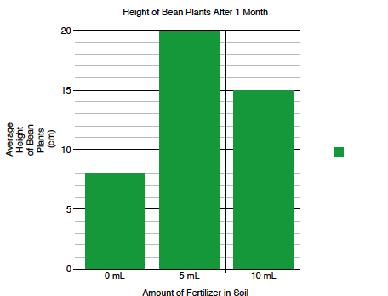 The purpose of a graph is to create a visual display of your data. Graphs are helpful because they show patterns. The type of graph that you make will depend on the data that you want to display. **Bar graphs** are best for discrete data, e.g. comparing objects or events. **Line graphs** are best for continuous data, e.g. changes over time. Below is a sample of a bar graph and a line graph.

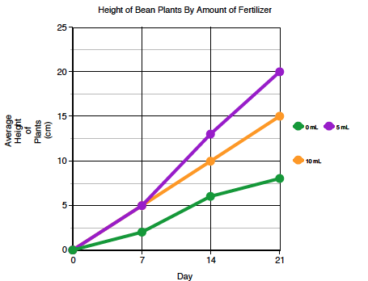

When you make a graph be sure that it has a title and that both the x- and y-axis are labeled. On the next page create your graph or make one on-line and paste it in this notebook. Click [here](http://nces.ed.gov/nceskids/createagraph/) or do a Google search for the Create A Graph website.

**Data Charts & Graphs cont’d**



Explain what your graph shows.

**Conclusion Due Jan 20th**

The conclusion is a place for you to share what you learned from conducting your experiment and analyzing your data. Your conclusion should be one to three paragraphs long. In your conclusion you should:

* Evaluate your hypothesis. Was your hypothesis correct?
* Explain what you found out.
* Use data to support your findings.
* Infer why your experiment turned out as it did.
* Explain why your findings are important. Who might benefit from what you learned?

**Display Board Due Jan 23rd**

Write a rough draft of your conclusion in the space below.

 Your display board should demonstrate all of the hard work that you have put into your science fair project. Don’t wait until the last minute! Use the information that you have recorded in this science fair notebook to help you decide what to write on each section of your board. The picture shows one example of how to set up your board. Your board may look a little different, depending on the experiment that you conducted.

Science Fair Notebook

SECTIONS FOR THE DISPLAY BOARD

**Question/Purpose:** An excellent question is interesting, creative, and worded scientifically.

**Research:** This section should include why you chose this project or what makes it interesting. Also include the information you learned about your topic by doing background research.

**Hypothesis:** An excellent hypothesis provides a possible answer to your question. The hypothesis is based on your background research.

**Materials and Procedures:** In this section you explain what you did to test your hypothesis. Include your materials and procedures. Be specific so that others understand what you controlled to make a fair experiment. If you did multiple trials be sure to include that in your procedures. Pictures are very appropriate in this section, but your pictures should not show people’s faces.

**Data and Observations:** Include a chart or graph to represent the data that you collected.

**Results:** Explain what your data shows. Describe patterns, trends, and any data that is unexpected.

**Conclusions:** A good conclusion will be 1 – 3 paragraphs long. Your conclusion should share what you learned through your investigation and why your findings are important.

**Science Fair Notebook:** Your science notebook should include the research you did for the project, a list of sources that you used for research, and all of the data and observations you recorded while conducting the experiment.

**Pre Approval: Grades 5-8 School Common Sense Safety Approval-Page 1**

All projects must be PRE-approved by the **school** before any project can get started. See the back of this sheet for ALL the details.

**Students-fill the top out and give to your teacher. PRINT CLEARLY.**

Name(s):

School:

My project uses:

* Animals
* People
* Bacteria/Pathogens
* Hazardous materials (weapons, fire, chemicals etc…)
* None of these

This is what my project is about:

**- - - - - - - - - - - - - - - - - - - - - - - - - - - - - - - - - - - - - - - - - - - - - - - - - -**

Teacher/Fair Coordinator

* Approved: I have reviewed the project and talked with the student (and parents if needed) and feel that it is safe and reasonable for the student to do. Steps are in place to get permission from participants, keep animals safe, avoid creating a pandemic of super-bacteria or burning down the school. I checked with the District or Regional Fair in case I wasn’t sure. Signatures on back of document.
* Denied: I have reviewed the project and DO NOT approve it due to safety concerns. I checked with the District and Regional Fair and they concur that this project is going to get a student disqualified or worse, hurt. Pick another idea.

**___________________________**

Printed Name of School Fair Coordinator

(Coordinator: Send your entire school’s forms to Stephanie Wood in a bundle)

**My Experiment will Involve the Following** (check all that apply):

**Human Subjects**



All human research projects must be **reviewed** and **approved** by a science teacher, a school administrator and one of the following: a psychologist, psychiatrist, medical doctor, physician’s assistant or registered nurse **before the student begins experimentation**. If they determine that there is more than minimal psychological or physical risk to the human subjects involved in the project, the student must receive written consent from each of the participants and written parental consent for students under 18 years old. If they determine that there are unacceptable risks involved the student must revise his or her project. *Please attach a copy of the surveys or tests* you intend to use with your research plan. Students may not publish or display information that identifies the human subjects.

**Non-Human Vertebrate Animals**



All projects involving non-human vertebrate animals must be **reviewed** and **approved** by two science teachers and a biomedical scientist (ex. a local veterinarian) **before the student begins experimentation.** Alternatives to the use of vertebrate animals must be explored and included in the student’s research plan. Experiments involving laboratory animals (rats, mice, hamsters, gerbils, rabbits, etc) cannot be conducted in a student’s home except for behavior studies on pets. Proper animal care must be provided daily, including weekends, holidays and vacations. Experimental procedures that cause unnecessary pain or discomfort are prohibited. Experiments designed to kill vertebrate animals are not permitted. Students may not perform euthanasia, except in emergency situations. Alcohol, acid rain, insecticide, herbicide and heavy metal toxicity studies are prohibited. Experiments with a death rate of 30 percent or higher are not permitted. Behavioral studies or supplemental nutritional studies involving pets or livestock may be done at home.

**Controlled Substances** (Prescription Drugs, Tobacco, Alcohol, etc)



All projects involving controlled substances must be **reviewed** and **approved** by two science teachers and a school administrator or biomedical scientist **before the student begins experimentation**. Students must adhere to all federal, state and local laws when acquiring and handling controlled substances. Only under the direction of a qualified scientist or designated supervisor may a student use federally controlled or experimental substances for therapy or experimentation. Students under 21 may not handle or purchase smokeless powder or black powder for science projects.

**Hazardous Substances or Devices** (Chemicals, Firearms, Welders, Lasers, Radioactive Substances, Radiation)



Students must adhere to federal and state regulations governing hazardous substances or devices. An adult must directly supervise experiments. Students working with hazardous substances or devices must follow proper safety procedures for each chemical or device used in the research.

**Potentially Hazardous Biological Agents**



(Bacteria, Mold, Fungi, Viruses, Parasites, Recombinant DNA (rDNA), Human or Animal fresh tissues, blood or body fluids, etc)

All projects involving potentially hazardous biological agents must be **reviewed** and **approved** by two science teachers and a biomedical scientist **before the student begins experimentation**. It is the responsibility of the student and the adults involved with the project to conduct a risk assessment. Risk assessment defines the potential level of harm, injury or disease to plants, animals and humans that may occur when working with biological agents. Risk assessment involves:

1. Assignment of the biological agent to a biosafety level risk group. **Students in grades 5-8 may only conduct research with biological agents determined to be at Biosafety Level 1 (BSL-1).** BSL-1 agents pose low risk to students or the environment and are highly unlikely to cause disease in healthy people, animals or plants. Examples of BSL-1 Microorganisms include: *Agrobacterium radiobacter, Aspergillus niger, Bacillus thuringiensis, Escherichia coli strain K12, Lactobacillus acidophilus, Micrococcus leuteus, Neurospora crassa, Pseudomonas fluorescens, and Serratia marcescens.* **Studies involving unknown microorganisms can be determined BSL-1 if the organism is collected in a plastic Petri dish or other non-breakable container and is sealed and remains sealed during the entire experiment.** Examples of BSL-1 rDNA studies include: Cloning of DNA in *E. coli K12, S. cerevesiae*, and *B. subtilis* host vector systems. Examples of BSL-1 Tissue studies involve the collection of non-infectious fresh tissues (not including blood or blood products) with little likelihood of microorganisms present. Projects involving blood or blood products are considered Biosafey Level 2. Plant tissues, established cell lines and cultures, meat from food stores or restaurants or packing houses, hair, teeth that have been sterilized, and fossilized tissue do not need to be treated as potentially hazardous biological agents.
2. Determine the level of biological containment available to the student researcher. **Biosafety Level 1 projects can be performed in a school laboratory but are prohibited in the home environment.** Standard microbiological practices must be used and all hazardous agents must be properly disposed of at the end of experimentation. The experiment must be supervised by a qualified scientist or a trained designated supervisor.

\***For a complete list of rules regarding all of the subjects listed above please visit the following website:** [**http://www.societyforscience.org/page.aspx?pid=312**](http://www.societyforscience.org/page.aspx?pid=312)

**If your project will include any of the subjects listed above, you must get all these signatures before you begin.**

**_______________________________ ________________________________ ________________________________**

**Science Teacher Date School Fair Coordinator Date Other professional (i.e. doctor, vet, scientist)**

**PRE APPROVAL-GRADES 5-8 SAFETY APPROVAL SCIENCE FAIR PROJECT RULES PAGE 2**